**Отчет по дисциплине «Базы данных»**

**Лабораторная работа №1**

Тюрин Иван Геннадьевич

БИБ191

30 Вариант

**Задание:**

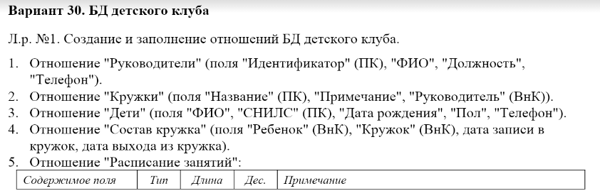

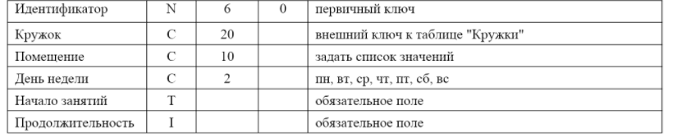

**Решение:**

CREATE DATABASE lab_1;

USE lab_1;

CREATE TABLE Managers (

id_manager serial PRIMARY KEY,

full_name VARCHAR(255) NOT NULL,

post VARCHAR(255),

telephone int

);

CREATE TABLE Clubs (

title VARCHAR PRIMARY KEY,

note VARCHAR(255),

manager_id int,

FOREIGN KEY (manager_id) REFERENCES managers (id_manager)

);

create type weekdays as enum ('пн', 'вт', 'ср', 'чт', 'пт', 'сб', 'вс');

create type audiences as enum ('A101', 'A102', 'A201', 'A202', 'B101', 'B102', 'B201');

CREATE Type gender as ENUM ('муж', 'жен');

CREATE TABLE Timetable (

id_clubs serial PRIMARY KEY,

name VARCHAR(20) NOT NULL,

room audiences NOT NULL,

day weekdays NOT NULL,

start_time TIME NOT NULL,

duration INTERVAL NOT NULL,

FOREIGN KEY (name) REFERENCES clubs (title)

);

CREATE TABLE Children (

SNILS CHAR(14) PRIMARY KEY,

full_name varCHAR(255) NOT NULL,

birthdate DATE NOT NULL,

gender gender NOT NULL,

telephone int NOT NULL

);

CREATE TABLE club_composition (

kid char(14) not NULL,

club VARCHAR NOT NULL,

credited date,

deducted Date,

FOREIGN KEY (kid) REFERENCES children (snils),

FOREIGN KEY (club) REFERENCES clubs (title)

);